Self intro
"Hi, I'm Ivan. I recently graduated with First Hon from City U of Hong Kong, double major in Business Decision Analytics and Information Management.
I have a strong passion for data science, and my academic background has given me a foundation in statistics and programming. That’s why I’m interest in this Junior Data Scientist role at Beta Labs—it perfectly aligns with my technical skillset and my passion to solve real-world business problems using data.
Over the past year, I have gained hands-on experience through several data-related internships. For instance, during my time at Langya AI, I built an automated Python ETL pipeline from scratch for over 3,000 global stocks. I was responsible for extracting, cleaning, transforming, and structuring large-scale financial data for manager to analyze stocks. This successfully replaced a manual updating process. I also developed linear regression models to examine the relationship between Famous ETF return and manager porf return, and explain the insight to manager for his decision-making.

"With my double major, I understand both business and technology. I know how companies work, and I know how to use data to solve their problems. so I can learn fast and am suitable for this role."

Why want to do this role and Beta Labs?
First, for my career, I just graduated and I want to start in an environment where I can learn fast and build a strong foundation, while working on problems that really matter to the business. Retail and luxury data give a lot of real, hands-on challenges — like personalization and customer behavior — which I think are a great place to start.
Second, I really like the culture of think big, start small, fail fast. In data science, you don't always get the right answer on the first try. It's more about testing ideas on a small scale, getting feedback quickly, and improving from there. As a junior, this makes me feel comfortable to try, make mistakes, and grow — instead of being afraid to start.
Third, I genuinely enjoy data science — cleaning data, analyzing it, building models, and turning results into insights that help the business make better decisions. Since Beta Labs uses AI and analytics to improve retail operations and customer experience, this is exactly the direction I want to grow in, because it combines technical skills with real business impact.

Question
1.
"What does success look like for someone in this role after the first six months, and what kind of skills or experience would help them grow into a more senior data science position here?" (like communication skills, more domain knowledge or tech skills?)
2.
"When working on a data science project here, how does the team typically collaborate with other departments, like marketing, or IT — for example, who defines the business question, and how involved would a Junior Data Scientist be in that process?"
3.
"Could you walk me through what a typical week looks like for a Junior Data Scientist here — for example, how much time is usually split between recurring reporting or dashboards versus more exploratory analysis or modelling work?"

Strength and Weakness
「我最大的優點是我能夠連結商業與資訊科技。得益於我的雙主修背景，我不會只把數據看作數字，而是能理解背後的商業邏輯。結合我的技術能力，我可以設計出直接解決真實商業問題、提升營運效率的數據管道和機器學習模型。」
Weaknesses:
「我意識到自己的缺點是有時在初期過於追求完美，導致把事情複雜化。例如在從零開始設計數據模型或自動化管道時，我會想覆蓋所有極端情況，有時會拖慢初期進度。
不過，我已經學會了敏捷開發的重要性。現在我會強迫自己先砌出一個最基本的原型（MVP），及早獲取反饋然後再逐步優化。這讓我能在不犧牲速度的情況下，依然保持高質素的產出。」

Pass project one – two (in ENG)

Python automation update pipitune
STAR Answer
Situation
My manager majorly use matlab to analyze data , he said using matlab to download historical stock data is not efficient.
Task
He asked me to use python to do ETL pipeline that could extract, clean, and update this data automatically, at scale, with minimal manual intervention."
Action
"I built a pipeline that pulls data from Yahoo Finance, converts tickers into the correct format across different exchanges, and only downloads new data instead of the full history each time to save processing time. I also added logic to automatically handle corporate actions like dividends and stock splits, retry failed downloads, and flag suspended stocks — while logging any errors clearly so issues could be reviewed."
Result

"The pipeline ran daily without manual work, reliably updating data for over 3,000 tickers, improving both efficiency and data accuracy. This gave the team a dependable data foundation to run our regression-based stock analysis."

Calculate linear regression of strategty vs common ETF
STAR Answer (Short)
Situation
"After building the ETL pipeline, the team needed a way to understand what was driving a portfolio's returns — specifically, how much of the performance came from broad market movement versus other underlying factors."
Task
"I was asked to build an automated framework that could take the target variable's return series and quantify its relationship with several explanatory variables, updated on a rolling basis."
Action
"I built a pipeline in Python using statsmodels that merged the target series with multiple explanatory variables, then ran ordinary least squares regression for each variable individually across different rolling time windows — like 10-day and 21-day — to capture both short-term and medium-term relationships. For each regression, I extracted the coefficient and t-statistic to measure both the strength and the statistical significance of each relationship, and exported the results automatically into a structured report."
Result
"This gave the team a repeatable, automated way to monitor how sensitive the target variable was to each explanatory factor over time, instead of doing this analysis manually."

Responsibility:
"Select features, build, and optimize classifiers using various machine learning techniques"
實際工作係做乜： 「Classifier（分類器）」顧名思義就係將顧客或者產品分類。例如建立一個預測模型去估計：
- VIP 流失預測 (Churn Prediction)： 預測呢位高淨值客戶下個月會唔會唔再買嘢（Yes/No）。
- 購買意向 (Propensity to Buy)： 預測某個客戶對今季新款手袋有冇興趣（High/Medium/Low）。

"Applies advanced statistical and machine learning techniques to build, maintain, and improve on multiple real-time decision systems"
• 實際工作係做乜： 「Real-time」通常指連卡佛官網或 App 上面嘅個人化推薦引擎 (Recommendation Engine)。當顧客將一件 $5,000 嘅外套加入購物車，系統要喺 0.1 秒內計算並彈出「Complete the Look（配搭建議）」嘅鞋同手袋。

Ab testing
• 背景（Hypothesis）：產品團隊認為目前的結帳流程要填太多資料（分 3 個頁面），如果改成「一頁式快捷結帳（One-page Checkout）」，能大幅提升付款成功率。
• 實驗設計：
- Control Group (A組)：維持原狀，顧客結帳時要分步按「下一步」跳轉 3 個網頁。
- Treatment Group (B組)：把所有地址、信用卡資料、運送選項整合在同一個頁面內。
• DS 的工作：當實驗跑了兩週後，收集兩組的轉化率數據。利用 Chi-Square Test（卡方檢驗） 或 Z-test 來驗證 B 組的轉化率提升是否在統計學上顯著（Statistically Significant），從而決定是否全線改版。

Data analysis project process
1. 定義問題 (Business Understanding)： 釐清商業目標與痛點。
例子： 發現 Lane Crawford 網店購物車棄置率很高，目標是找出原因並提高轉化率。
2. 數據收集與清理 (Data Preparation / ETL)： 拉取資料並處理缺漏值與異常值，確保數據質量。
例子： 用 SQL 從數據庫抓取瀏覽紀錄與交易資料，清理掉測試帳號與重複下單的雜訊。
3. 探索性數據分析 (Exploratory Data Analysis / EDA)： 利用圖表與統計找出規律並提取特徵 (Feature Engineering)。
例子： 繪製圖表發現結帳步驟超過 3 頁時，客戶放棄付款的比例飆升 40%。
4. 建立與優化模型 (Modeling)： 根據目標選用統計方法或機器學習演算法進行訓練與調參。
例子： 建立一個 Logistic Regression 分類器，預測哪些顧客在加入購物車後有高風險會流失。
5. 評估與實驗驗證 (Evaluation & A/B Testing)： 用指標評估模型，並透過實驗驗證商業效益。
例子： 推出「一頁式快捷結帳」，進行 A/B Testing 兩週後，用 Chi-Square Test 驗證新版轉化率是否有顯著提升。
6. 部署與監控 (Deployment & Monitoring)： 將分析結果報告化或將模型部署上線並持續監控。
例子： 將「一頁式結帳」全線上線，並把流失預測模型包裝成 API 嵌入 App，即時觸發折扣優惠，同時在 Tableau Dashboard 監控每日轉化率。\

10 Python libraries in data science
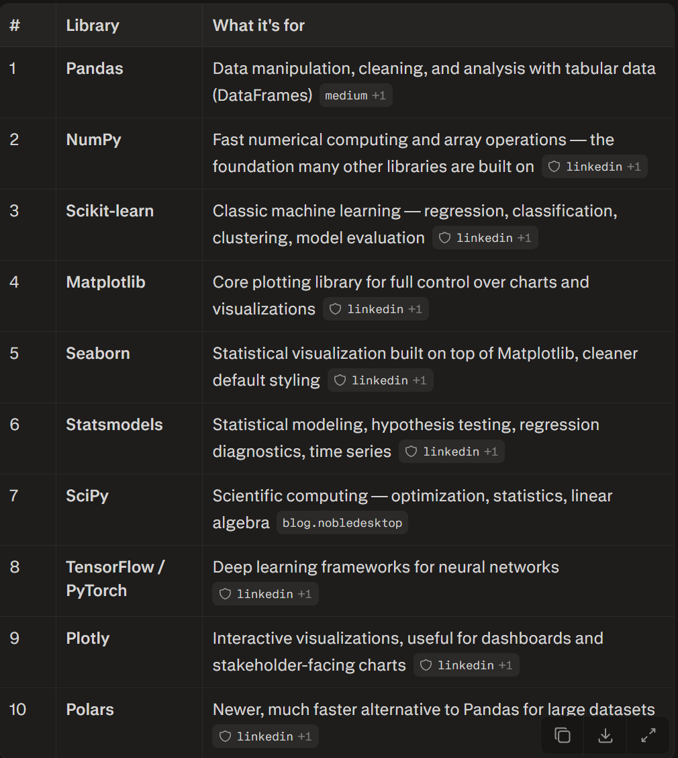

Company information
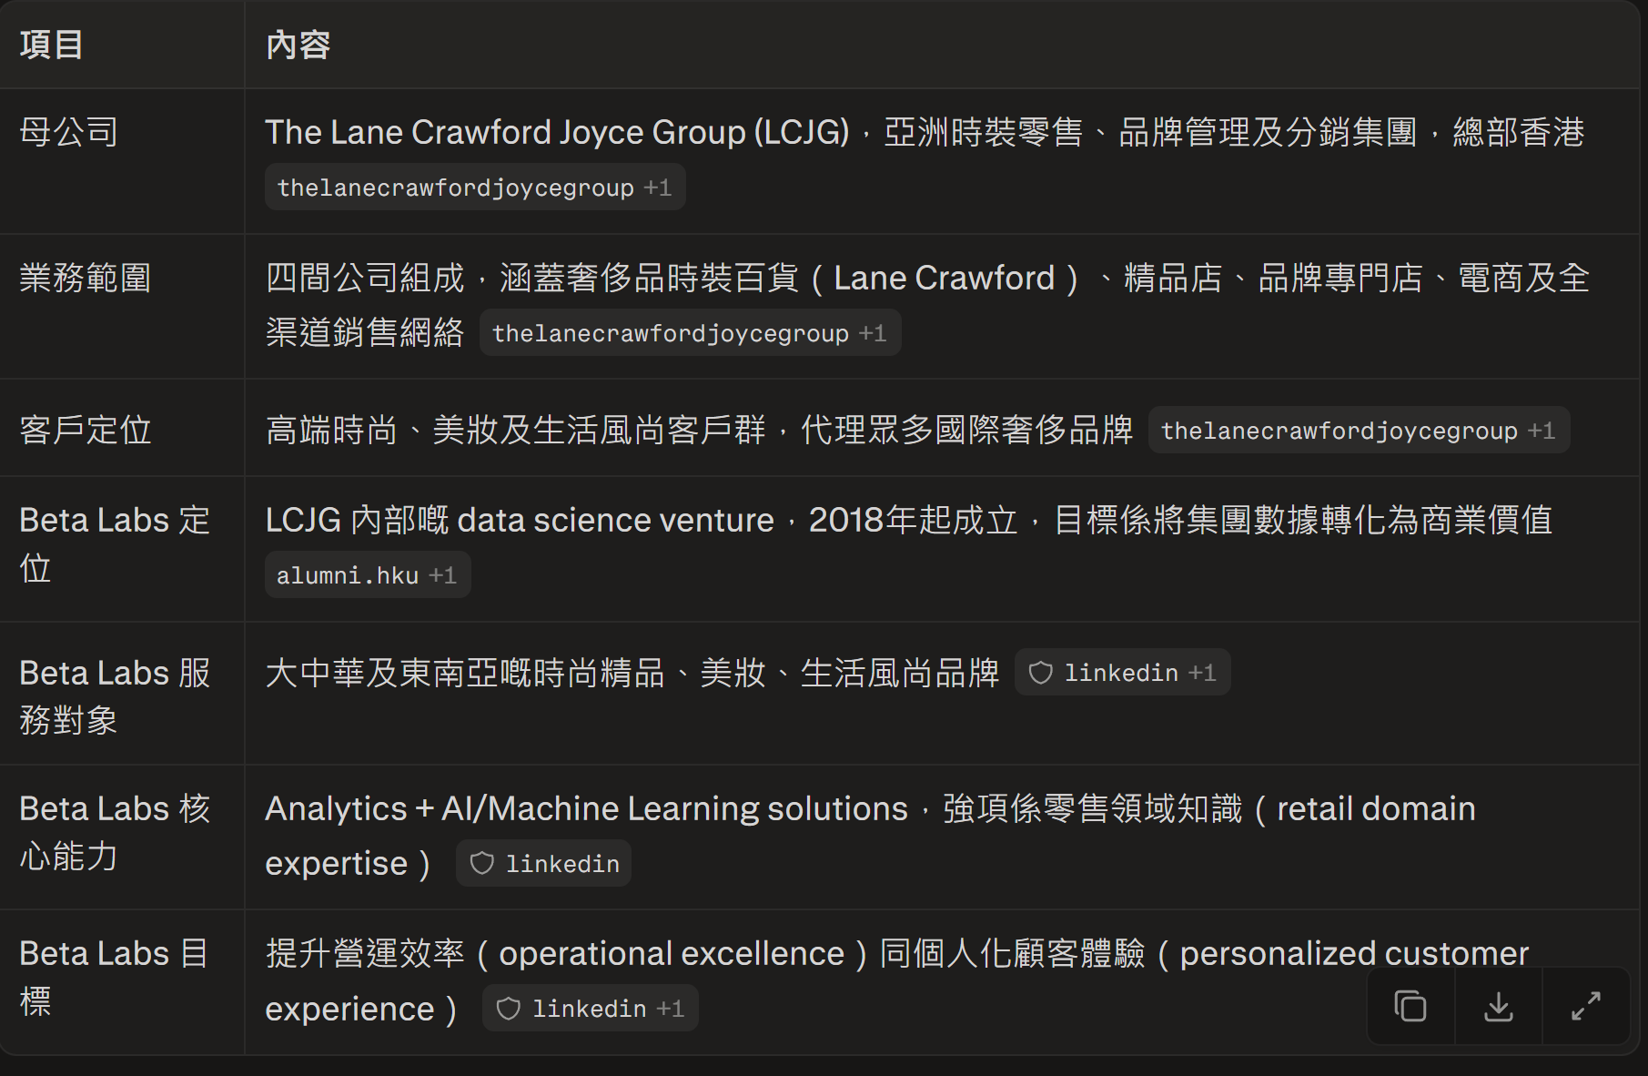

Data science question

Statistics & Probability
Hypothesis testing / p-value 是什麼？
"P-value tells us the probability of seeing this result (or more extreme) if the null hypothesis were true. If it's below our significance threshold, typically 0.05, we reject the null hypothesis."
Type I vs Type II error？
"Type I error is a false positive — rejecting a true null hypothesis. Type II is a false negative — failing to reject a false null hypothesis. There's usually a tradeoff between the two."
幾時 A/B test 可以 "stop"？
"I would stop when we've reached the pre-calculated sample size needed for statistical power, not just when results look significant early — stopping too early risks false positives."

Machine Learning Concepts
Linear regression assumptions？
"Linearity between variables, independence of errors, homoscedasticity (constant variance of errors), and no severe multicollinearity between predictors."
Overfitting vs underfitting？
"Overfitting means the model learns noise in training data and performs poorly on new data. Underfitting means the model is too simple to capture the pattern at all. Cross-validation and regularization help balance this."
Bias-variance tradeoff？
"High bias means the model is too simple and misses patterns; high variance means it's too sensitive to training data and doesn't generalize. The goal is to find a model complexity that balances both."
Precision/recall，幾時用邊個？
"Precision matters when false positives are costly — like flagging fraud incorrectly. Recall matters when missing a true case is costly — like missing a churn risk. For imbalanced data, I'd look at both rather than just accuracy."
點處理 missing data / imbalanced dataset？
"For missing data, I'd check if it's random or systematic, then either impute, drop, or flag it depending on the pattern. For imbalanced data, I'd consider resampling, class weights, or choosing metrics like F1 instead of accuracy."

